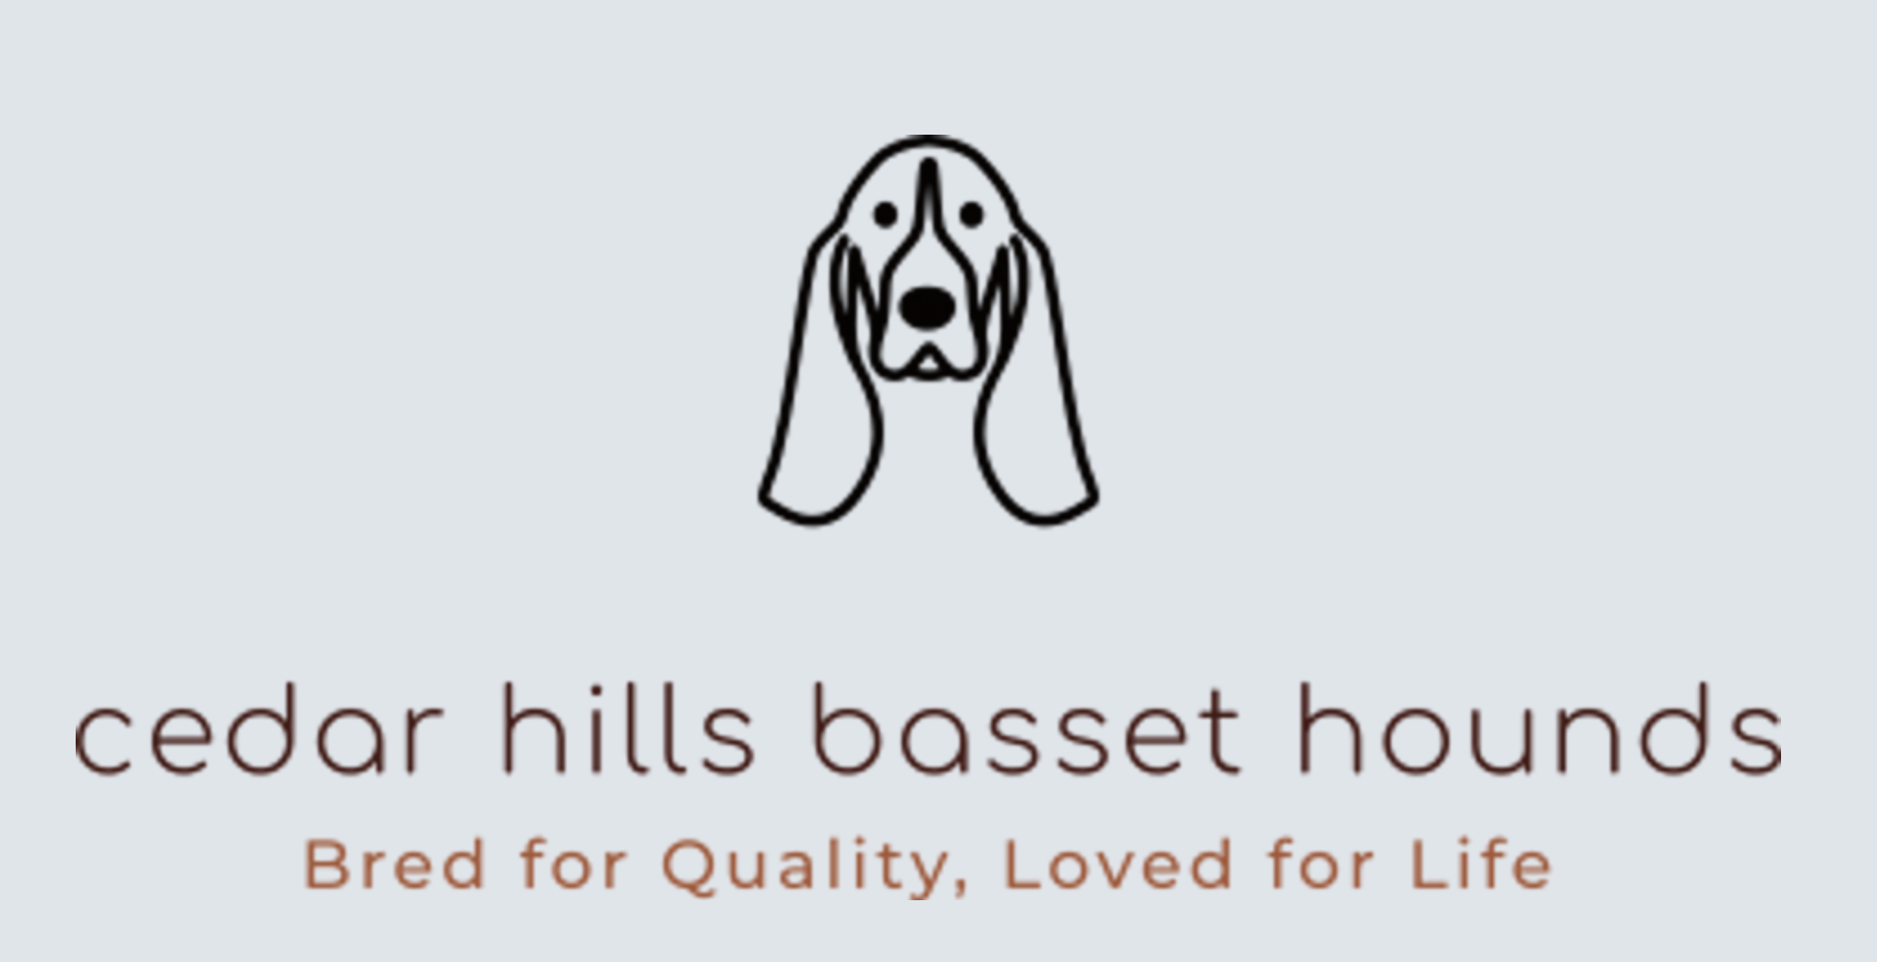

Puppy Contract

Thank you for choosing a Cedar Hills Basset to join your family. We look forward to staying in contact and receiving updates about your new puppy. Please read the following contract carefully because it outlines what is expected for the lifetime of this puppy.
Deposits and Payment
By placing this deposit of $500, the buyer agrees to the following:
- The deposit is non-refundable.
- If puppies are not born yet, half ($250) of the non-refundable deposit can be paid to join our waiting list. The other half ($250) is due when puppies are born.
- The complete cost of this puppy is $1800 USD for limited AKC registration.
- In the event that your puppy becomes ill or dies while at the breeder’s kennel, your deposit will go toward another puppy in the litter (if available) or transfer to a future litter of equal quality.
- Breeder reserves the right to refund the deposit and refuse sale at any time if the breeder feels it is no longer in the puppy’s best interest to be placed with the buyer.
- Puppy must be paid in full before he/she leaves our kennel. No Exceptions.
AKC Limited Registration
- Your puppy is sold with limited AKC registration. The dog is never to be bred/shown and is pet only.
- The buyer agrees to spay/neuter the puppy between 12-18 months. The breeder will hold AKC registration certificates until official documentation of the spay/neuter has been sent from the buyers licensed veterinarian. DO NOT alter your pet until at least a year old to prevent growth issues.
- Cedar Hills Kennel name will be assigned to the AKC registration documents of all the puppies. Individual names will start with the same letter assigned to each litter. The call name doesn’t need to match the registered name.
- Breeder agrees to pay for and register all the puppies with the American Kennel Club (AKC).
- If the dog is bred on purpose or accident, the buyer agrees to pay the breeder $1500 penalty for each puppy produced for breaking this agreement. Payable when the puppies are 8 weeks old.

Caring for your Puppy
Vaccination and Worm Treatment Schedule
Puppies will leave the breeder no earlier than 8 weeks of age. Your puppy has been vaccinated for Distemper/Parvo at 8 weeks. The buyer agrees to complete the 2nd set at 12 weeks and the 3rd set at 16 weeks which includes rabies. All puppies have had worming treatments every 2 weeks from birth with Pyrantel. Breeder will provide a vaccination book to keep track of the puppy’s health record.
NuVet Plus- Buyer agrees to keep their puppy/dog on the NuVet Plus for at least the first two years of the puppy’s life. It’s not just a vitamin, it’s an immune system builder. Quality dog foods provide everything needed to sustain life but virtually all of them are cooked during the manufacturing process. The heat from cooking causes much of the nutrients to be lost. NuVet Plus is cold processed allowing all the benefits of each ingredient to be retained which gives your puppy an extra layer of protection during the critical first couple years of life. All Cedar Hills Bassets are on NuVet Plus daily and they absolutely love it. By using the breeder code below, Nuvet keeps me informed of your purchase and your commitment to your Basset Hound’s health.
The health guarantee is contingent upon the use of Nuvet Plus
To Order
Nuvet 1-800-474-7044 from 8:00 AM to 6:00 PM Pacific Time Breeder Code: 15333 (Must be used)
Or order at www.nuvet.com using the breeder code 15333
Feeding Requirements- Only feed your Basset Hound LARGE BREED puppy food. The litter has been raised on NutriSource Large Breed Puppy Kibble (In the purple bag). At 6-8 months I recommend switching to a regular adult diet. Basset Hounds that grow too quickly can develop PANO, which is similar to growing pains, causing them to limp. Many vets are unfamiliar with this condition and will suggest a correction surgery. The buyer agrees not to have any surgeries done for the elbows or hips without consulting the breeder first.
Microchip- Your puppy is microchipped. In the event that your puppy gets lost and is recovered by a shelter or vet clinic, the chip is permanent identification. My contact information is registered as the primary contact and I have listed you as the secondary contact. I, the breeder, pay for the registration of the chip because I will never have one of my dogs homeless, this is part of being a responsible breeder. If the buyer doesn’t claim the puppy within 48 hours of being contacted, I may personally arrange to have the puppy/dog returned to Cedar Hills Bassets kennel. The buyer agrees to forfeit all AKC registration ownership back to the breeder. This must take place within a week of the breeder claiming the puppy/dog.

Health Guarantee
Your puppy will leave Cedar Hills Basset Hounds with a health certificate showing that to the best of my knowledge, your puppy left my kennel healthy and is free of communicable diseases. Any health-related findings would be disclosed to the buyer on this contract.
72-Hour Money Back Health Guarantee:
1. The Buyer agrees to take the above listed puppy to a licensed veterinarian within a period of 72-hours from the date and time of receiving the puppy or this guarantee is null and void.
2. If in the first 72-hours you are dissatisfied with your puppy for any reason, you (the buyer) are welcome to return the puppy to my kennel for a refund of the original purchase price less the non-refundable $500 deposit.
3. All transportation costs are the buyer’s responsibility. 4. No cash refunds after the first 72-hour period.
Two-Year Replacement Puppy Genetic Health Guarantee
1. To qualify for the Two-Year health guarantee you must do the following:
.Give your puppy/dog recommended dosage (1 wafer per day) from 10 weeks - 2 years old.
2. If the above conditions are met, and your puppy is discovered to have a life-threatening genetic defect in their first 2 years of life, confirmed and documented by two separate licensed veterinarians, the breeder agrees to replace the puppy/dog with a puppy from a future litter of the same quality and gender at no charge to the buyer. 3. The breeder reserves the right to refund the original purchase price of the puppy (minus the $500non- refundable deposit) if the breeder decides not to place another puppy with the buyer.
4. No cash refunds given.
The following are not a part of the 72-Hour or 2-Year Health Guarantee.
1. These guarantees’ do not cover what is considered normal for the breed such as: Cherry Eye, Entropion, Skin allergies, Bloat, Ear Infections, and Panosteitis (PANO), and Pyometra.
2. Normal puppy maladies such as: Parasites, worms, ear infections, ringworm, giardia, or coccidia.
3. Minor physical defects such as: navel or inguinal hernias, uneven bites, undescended testicles, type I or II heart murmurs, or any other non-life-threatening problem.
4. Under no circumstances shall the breeder be liable for consequential, incidental, or special damages resulting from negligence and environmental factors such as: poor temperament due to lack of training and socialization, weight, jumping, autoimmune disorders, starvation, neglect, etc.
5. The breeder will not be responsible for contagious disease such as: Parvo, Distemper, Corona Virus, Kennel Cough, mange, or scabies as they are highly contagious and can be contacted immediately.

Lifetime Open Door Policy
If you can no longer keep your Basset Hound for any reason, at any age, I will happily welcome him/her back to Cedar Hills Bassets kennel. No questions asked. All Cedar Hills Basset Hounds will ALWAYS have a home here. I do require that all health records and AKC paperwork be transferred back with the dog. Buyer agrees to contact the breeder immediately if rehoming is needed. I, the breeder, have a large network of resources and I am regularly contacted by the perfect homes! If you are transferring ownership to a family member, you are still required to notify the breeder with their contact information.
Signatures and Dates
Here at Cedar Hills Bassets we have gained a great deal of knowledge about the basset hound breed over the years and keep learning as information becomes available. We hope our experience can be seen by the quality of our dogs. We want to provide families with bassets that are healthy and happy. We know when you get a Basset Hound, or any dog; you want it to be a member of your family for as long as possible. Thank you for adopting a Cedar Hills Basset!
We the undersigned have read this entire contract (3 pages), which we mutually agree and accept as legally binding.
Breeder: _________________________________________ Date: ______________________
Buyer(s): _________________________________________Date: _______________________

